HONORS CHEMISTRY • UNIT 3
Chemical Bonding
Why atoms stick together, how they share or trade electrons, and how the shape and polarity of a molecule decide how a substance behaves.

HOW TO USE THIS PACKET
Write definitions in your own words, draw every structure yourself and use the empty space for questions. LAB CORNER boxes are things you would see or do at a lab bench. The shape chart in 3.4 is the one page to keep for the rest of the year.

What we will learn
3.1 | Types of chemical bonds: ionic and covalent
3.2 | Properties of ionic and covalent compounds
3.3 | Lewis diagrams for ionic and covalent compounds
3.4 | Lewis structures & VSEPR theory (shapes and angles)
3.5 | Bond polarity & molecular polarity
★ | Extra practice & unit review

By the end of this unit I can…
• Explain what a full octet is and how atoms reach one by losing, gaining or sharing electrons.
• Predict whether a compound is ionic or covalent and describe the bond using metals/non-metals and electronegativity.
• Connect bonding type to properties: melting point, state at room temperature and electrical conductivity.
• Use Lewis dot diagrams to model ionic compounds and to draw Lewis structures for covalent molecules and polyatomic ions.
• Compare single, double and triple bonds in terms of bond length and strength.
• Use VSEPR theory to predict molecular shapes and bond angles.
• Use electronegativity, bond dipoles and shape to decide whether a molecule is polar or non-polar.
TOPIC  3.1 | Types of Chemical Bonds  Octet rule • ionic bonds • covalent bonds

BIG IDEA
Atoms bond to reach a full outer shell of 8 electrons (an octet; 2 for hydrogen and helium), the arrangement of the noble gases. They get there in one of two ways: transfer electrons (ionic bond) or share electrons (covalent bond).

Key vocabulary — write each definition in your own words
Term | Definition (your words) | Example / sketch
Octet | How many electrons? Which elements are the exception?
Ionic bond | Between what kinds of elements? What do the electrons do?
Covalent bond | Between what kinds of elements? What do the electrons do?
Cation / anion | Which one is formed by losing electrons?
Molecule | Is NaCl a molecule? Why or why not?
Bond order (single / double / triple) | How many electrons are shared?

THINK OF IT LIKE… TRADING CARDS VS. SHARING A TOY
An ionic bond is like a trade where one kid hands over a card for good and the two are now stuck together by the deal (opposite charges). A covalent bond is two kids sharing one toy: neither owns it outright, and the toy keeps them together.

What does it mean to have a full octet?
1. In your own words, what is a full octet and why do atoms “want” one?

Ionic bonds
2. Which type of element typically forms a cation, and does it give or take electrons? Which type forms an anion, and does it give or take electrons?

CUES / KEY WORDS  Metal  Non-metal  Why does the ion form? | HOW A SODIUM ATOM AND A CHLORINE ATOM FORM AN IONIC BOND

Predicting ion charges
Use the periodic table. For each element: count the valence electrons, decide whether the atom loses or takes electrons, and give the ion’s charge.
Element | # of valence e⁻ | Lose or take e⁻? | Cation or anion? | Ion charge
Sodium
Fluorine
Aluminum
Boron
Nitrogen
Sulfur

QUICK RULE
• Group 1 → 1+, Group 2 → 2+, Group 13 → 3+.
• Group 15 → 3−, Group 16 → 2−, Group 17 → 1−.
• Transition metals often form more than one charge (Fe²⁺ or Fe³⁺); you will see these in Unit 4.

Covalent bonds
3. How is a covalent bond different from an ionic bond? Talk about the elements that form it and what happens to the electrons.

4. Some compounds contain single, double and triple bonds. What is the difference between them?

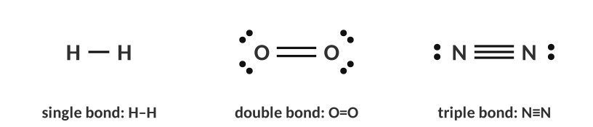
Single, double and triple bonds.
Ionic or covalent?
SHORTCUT
metal + non-metal → ionic
non-metal + non-metal → covalent
(If you are unsure, compare electronegativity: a difference larger than about 1.7 means ionic. See 3.5.)

Compound | 1st element: metal or non-metal? | 2nd element: metal or non-metal? | Ionic or covalent?
NO₂
MgBr₂
CaO
PI₃
SO₂
CaI₂

More practice | Ionic or covalent?
KCl
CCl₄
Li₃N
H₂O
Al₂O₃
CH₄
NH₄Cl

5. An ionic bond forms when…
A) two non-metals share electrons
B) a metal transfers electrons to a non-metal
C) two metals share electrons
D) two noble gases attract

6. How many electrons are shared in a double bond?
A) 2
B) 4
C) 6
D) 8

7. Which element is most likely to form a 2− ion?
A) Na
B) Cl
C) O
D) Mg

8. Which compound is covalent?
A) MgO
B) SO₂
C) KBr
D) CaCl₂

TOPIC  3.2 | Properties of Ionic and Covalent Compounds  Melting point • state • conductivity • brittleness

BIG IDEA
The kind of bond decides how a substance behaves: ionic compounds are hard, brittle, high-melting solids that conduct only when their ions can move; covalent (molecular) compounds usually melt at low temperatures and do not conduct.

Key vocabulary — write each definition in your own words
Term | Definition (your words) | Example / sketch
Crystal lattice | What holds it together?
Formula unit | How is it different from a molecule?
Melting point | What are you overcoming when a solid melts?
Electrical conductor | What must be present?
Electrolyte | Is a sucrose solution an electrolyte?

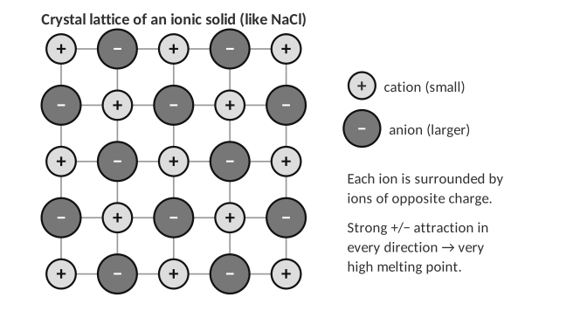
Melting points tell you about the bond
The table lists data for six substances. Classify each as ionic or covalent, then answer the questions that follow.
Substance | Ionic or covalent? | Melting point | State at room temp.
CaCl₂ |  | 772 °C | solid
H₂O |  | 0 °C | liquid
MgO |  | 2852 °C | solid
NH₃ |  | −77 °C | gas
SrO |  | 2531 °C | solid
H₂S
C₆H₁₂O₆ |  | 146 °C | solid

1. Some compounds have a large difference in melting point. Use the type of bond to explain why the ionic compounds melt at much higher temperatures.

2. Based on this trend, do you expect H₂S to have a high or low melting point? Explain using the bond found in H₂S.

Why ionic crystals are brittle
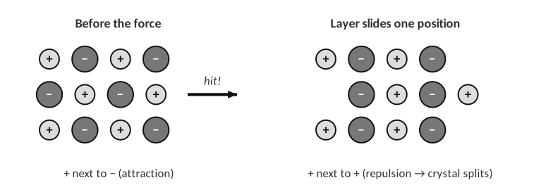
A hammer blow slides one layer of ions.
3. Explain why a salt crystal shatters when you hit it, while a metal bends.

LAB CORNER • Conductivity testing

A student uses a conductivity tester (two electrodes, a battery and a light bulb) to test substances. If current can flow through the sample, the bulb lights.
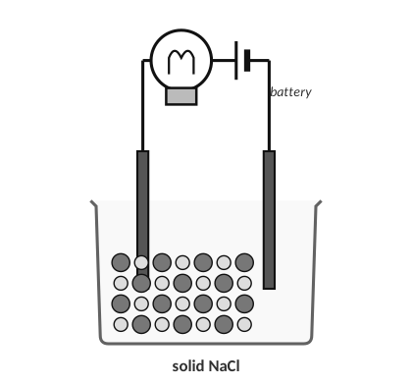 | 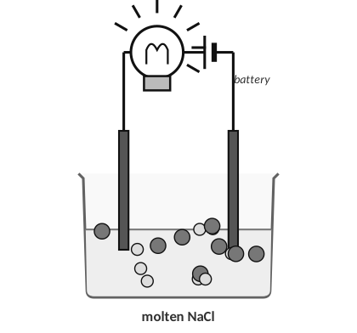
A: solid NaCl | B: molten NaCl

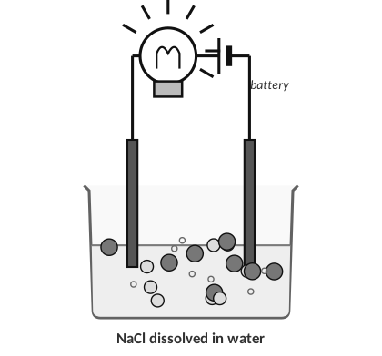 | 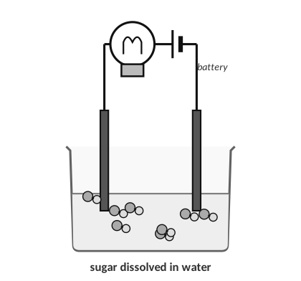
C: NaCl dissolved in water | D: sucrose dissolved in water

[ IMAGE GOES HERE ]
Optional: conductivity beakers from the homework

4. For a substance to conduct electricity, what must be present?

5. Which beakers should the student expect to light the bulb? Explain.

6. For the beakers you did not choose, explain why they do not conduct.

7. Predict: would distilled water light the bulb? Would tap water? Explain.

Property | Ionic compounds | Covalent (molecular) compounds
Particles
Melting / boiling point
State at room temp.
Conducts as a solid?
Conducts when molten or dissolved?
Hardness

8. Which substance would conduct electricity when melted but not as a solid?
A) C₆H₁₂O₆
B) MgO
C) H₂O
D) NH₃

9. Why does CaCl₂ have a much higher melting point than H₂O?
A) covalent bonds are stronger
B) ionic attractions among many ions are strong
C) water has no bonds
D) CaCl₂ is a gas

10. Which of these solutions does NOT conduct electricity?
A) KBr(aq)
B) NaOH(aq)
C) C₁₂H₂₂O₁₁(aq)
D) HCl(aq)

TOPIC  3.3 | Lewis Diagrams for Ionic and Covalent Compounds  Electron transfer • shared pairs • bond length

BIG IDEA
A Lewis diagram is a bookkeeping tool for valence electrons. For ionic compounds it shows electrons moving from metal to non-metal; for covalent compounds it shows shared pairs (bonds) and lone pairs.

Key vocabulary — write each definition in your own words
Term | Definition (your words) | Example / sketch
Lewis dot diagram (atom) | How many dots does carbon get?
Bonding pair | How is it drawn?
Lone pair | Which atom owns it?
Formula unit (ionic) | How do you find the ratio of ions?
Bond length | What is the trend for single, double and triple?

Ionic compounds: show the electron transfer
STEPS
1. Draw each atom with its valence electrons as dots.
2. Draw an arrow from each metal to the non-metal for every electron transferred.
3. Draw the ions in brackets: the cation shows NO dots (its outer shell is gone); the anion shows 8 dots.
4. Write the charge outside the bracket, and use as many metal atoms as it takes so that the electrons given = electrons taken.

WORKED EXAMPLE — POTASSIUM OXIDE
Use Lewis dot diagrams to show why potassium oxide is K₂O.

Work it out here:

Answer: __________________________________
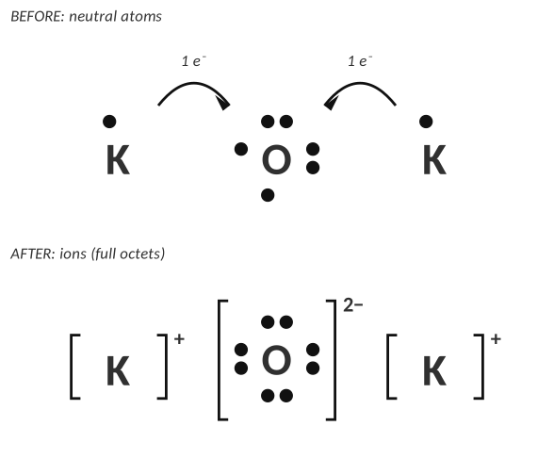
Potassium oxide: two K⁺ for each O²⁻.
Your turn
Draw Lewis dot diagrams (with arrows and brackets) for each compound and write its formula.
1. Calcium oxide: calcium + oxygen
Diagram and formula:

2. Lithium nitride: lithium + nitrogen. (The label on a bottle has worn off, but the student knows it contains lithium and nitrogen.)
Diagram and formula:

3. Magnesium chloride: magnesium + chlorine.
Diagram and formula:

4. Both K₂O and CaO contain oxygen. Explain why one formula has a subscript 2 and the other doesn’t.

Covalent compounds: Lewis structures step by step
STEPS
1. Count total valence electrons (add one electron for each negative charge; subtract one for each positive charge).
2. Skeleton: put the least electronegative atom in the middle (never H, never F). Connect the atoms with single bonds (2 e⁻ each).
3. Outer atoms first: add lone pairs to the outside atoms until each has 8 (H gets 2).
4. Leftover electrons go on the central atom.
5. If the central atom has fewer than 8, move a lone pair from an outer atom to make a double (or triple) bond.
6. Check: every atom has an octet (H has 2), and the electron count matches step 1.

WORKED EXAMPLE — WATER
Draw the Lewis structure of H₂O.

Work it out here:

Answer: __________________________________
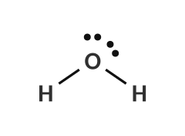
WORKED EXAMPLE — CARBON DIOXIDE
Draw the Lewis structure of CO₂.

Work it out here:

Answer: __________________________________
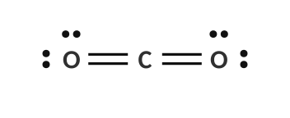
WORKED EXAMPLE — NITRATE ION
Draw the Lewis structure of NO₃⁻.

Work it out here:

Answer: __________________________________
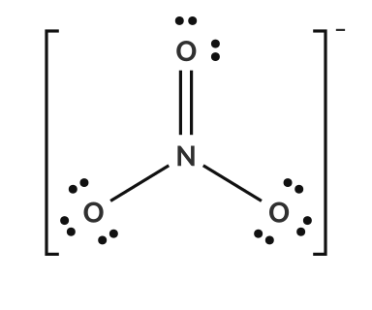
Count the electrons
Species | Valence-electron count | Total
NH₃
CH₄
HCN
SO₂
PCl₃
NH₄⁺
CO₃²⁻

Practice: draw the Lewis structures
Molecule | Lewis structure (draw it here)
NH₃
CH₄
HCN
SO₂
CH₂O
C₂H₄

Bond length and bond strength
A student is interested in the bond lengths of ethane (C₂H₆), ethene (C₂H₄) and ethyne (C₂H₂). Each carbon must have 8 electrons (4 bonds in total) and each hydrogen 2.
Compound | C–C bond type | Lewis structure | Bond length (pm) | Bond energy (kJ/mol)
C₂H₆ |  |  | 154 | 348
C₂H₄ |  |  | 134 | 614
C₂H₂ |  |  | 120 | 839

5. Which of the carbon–carbon bonds is the shortest? Explain using the attraction between protons and electrons.

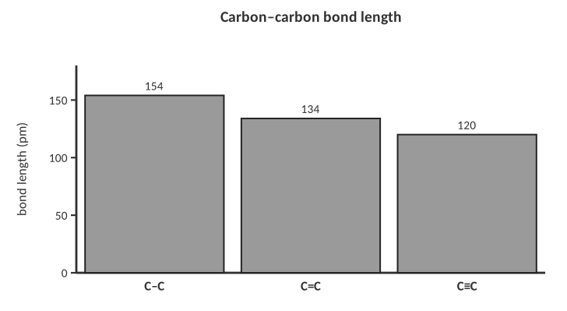
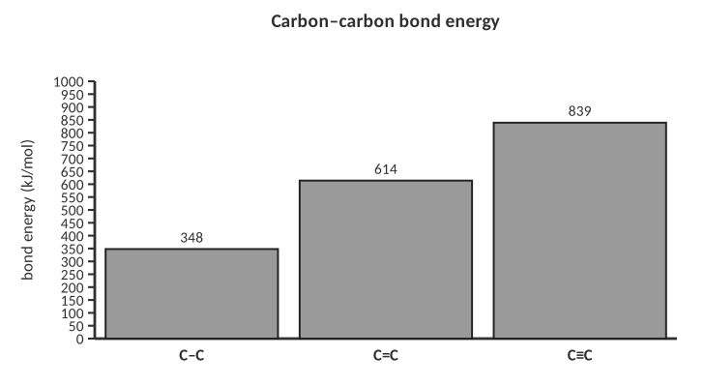
6. Describe the relationship between the number of shared pairs, bond length and bond energy.

7. Which is the correct total number of valence electrons for the Lewis structure of PO₄³⁻?
A) 29
B) 32
C) 30
D) 26

8. How many lone pairs are on the central atom of H₂O?
A) 0
B) 1
C) 2
D) 3

9. A compound is made of Mg²⁺ and N³⁻. What is the formula?
A) MgN
B) Mg₂N₃
C) Mg₃N₂
D) Mg₃N

TOPIC  3.4 | Lewis Structures & VSEPR Theory  Electron domains • shapes • bond angles

BIG IDEA
VSEPR (Valence Shell Electron Pair Repulsion) says that electron pairs around a central atom repel each other, so they spread out as far apart as possible. The resulting arrangement of the atoms is the shape of the molecule.

Key vocabulary — write each definition in your own words
Term | Definition (your words) | Example / sketch
Electron domain | What counts as one domain?
Electron geometry | Do lone pairs count?
Molecular shape | Do lone pairs count?
Bond angle | How is it measured?
VSEPR theory | Why do molecules have shapes?

THINK OF IT LIKE… TIED-TOGETHER BALLOONS
Tie 2 balloons together and they point in opposite directions (180°). Tie 3 and they make a flat triangle (120°). Four balloons form a tetrahedron (109.5°). Balloons are electron domains: they push each other apart as far as the knot allows. A fatter balloon (a lone pair, which takes more room than a bond) squeezes the others slightly closer.

In your own words: what is the big idea of VSEPR?

HOW TO NAME A SHAPE
1. Draw the Lewis structure.
2. Count the electron domains on the central atom (each bond, whether single, double or triple, counts once; each lone pair counts once).
3. Count how many of the domains are lone pairs (E).
4. Use the chart below: the number of domains gives the electron geometry; the lone pairs remove positions to give the molecular shape.

The VSEPR chart (fill in the name and angle of every shape)
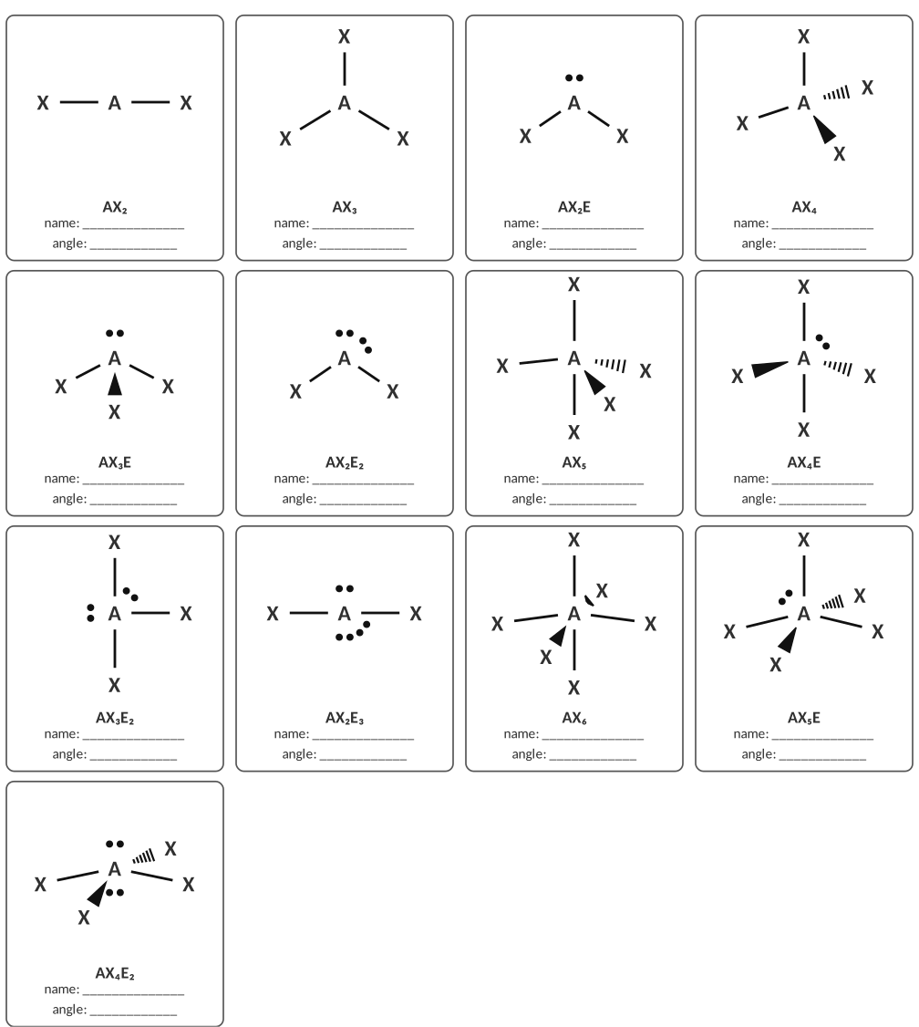
A = central atom, X = bonded atoms, E = lone pairs. Write the shape name and the ideal angle in each box.
Total domains | Electron geometry | Lone pairs (E) | Molecular shape
2 |  | 0
3 |  | 0 / 1
4 |  | 0 / 1 / 2
5 |  | 0 / 1 / 2 / 3
6 |  | 0 / 1 / 2

Worked examples
WORKED EXAMPLE — SHAPE OF NH₃
Give the Lewis structure, domains, shape and angle for NH₃.

Work it out here:

Answer: __________________________________
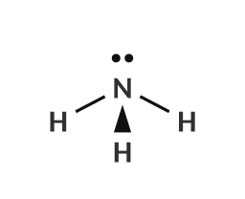
WORKED EXAMPLE — SHAPE OF CO₂
Give the shape and angle of CO₂.

Work it out here:

Answer: __________________________________
Practice: Lewis structure, shape and angle
Draw each Lewis structure, then name the shape and the bond angle(s).
Compound | Lewis structure | Shape | Angle(s)
NO₃⁻
OF₂
PF₅
CO₂
PH₃
SCl₆

Identify the shape and angle of each structure shown
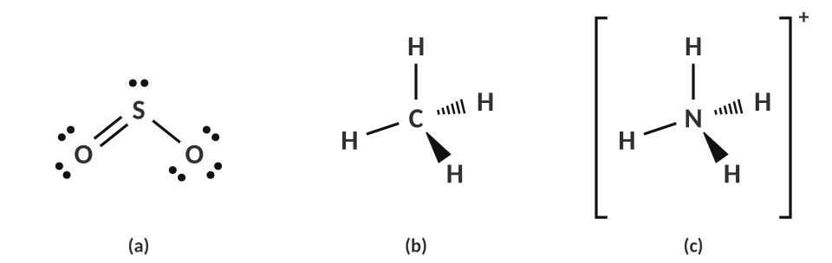
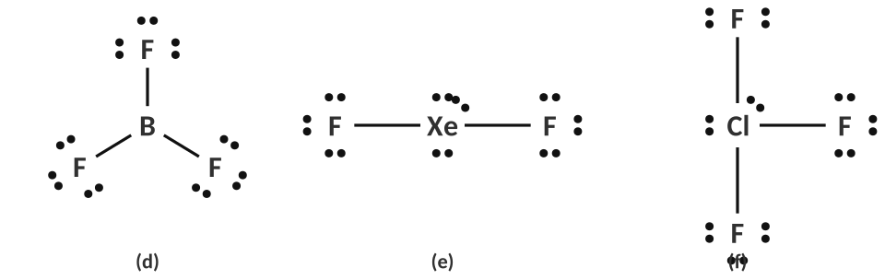
 | Domains on central atom | Electron geometry | Molecular shape | Angle
(a) SO₂
(b) CH₄
(c) NH₄⁺
(d) BF₃
(e) XeF₂
(f) ClF₃

Shape around each atom of a larger molecule
Acetic acid (vinegar) has several “central” atoms. Name the shape and bond angle around each atom marked (a), (b) and (c).
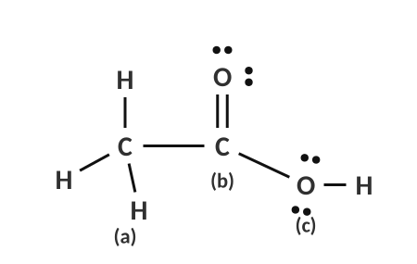
[ IMAGE GOES HERE ]
Optional: the large molecule from the homework

Atom | Domains | Shape | Angle
(a) the CH₃ carbon
(b) the C=O carbon
(c) the O–H oxygen

1. Why is the angle in H₂O (104.5°) smaller than the ideal tetrahedral angle of 109.5°?

2. Both CO₂ and SO₂ have three atoms, but one is linear and the other is bent. Explain the difference.

3. What is the shape of a molecule with 4 electron domains, 2 of which are lone pairs?
A) linear
B) bent
C) trigonal pyramidal
D) tetrahedral

4. PF₅ has what molecular shape?
A) octahedral
B) trigonal planar
C) trigonal bipyramidal
D) square planar

5. What is the approximate bond angle in CH₄?
A) 90°
B) 104.5°
C) 109.5°
D) 120°

6. Which species is trigonal planar?
A) NH₃
B) BF₃
C) PCl₃
D) H₂O

TOPIC  3.5 | Bond Polarity & Molecular Polarity  Electronegativity • dipoles • shape decides polarity

BIG IDEA
Electrons in a covalent bond are not always shared equally. The atom with the larger electronegativity pulls harder and becomes slightly negative. Whether the whole molecule is polar then depends on its shape: do the pulls add up or cancel?

Key vocabulary — write each definition in your own words
Term | Definition (your words) | Example / sketch
Electronegativity | Which element has the highest value?
Polar covalent bond | What is unequal about it?
Non-polar covalent bond | When does it happen?
Dipole / partial charge (δ+, δ−) | What does the arrow show?
Polar molecule | Two things that determine it?

THINK OF IT LIKE… TUG-OF-WAR
Two teams pull on a rope (the shared electrons). If the teams are equally strong the flag stays in the middle (non-polar). If one team is stronger, the flag shifts toward them (polar). In a molecule with several teams pulling in different directions, it can still end in a draw: if three equal teams pull at 120° from each other, the flag doesn’t move (BF₃).

Step 1: the bond
RULE OF THUMB (ΔEN = DIFFERENCE IN ELECTRONEGATIVITY)
ΔEN < 0.4 → non-polar covalent
0.4 ≤ ΔEN ≤ 1.7 → polar covalent
ΔEN > 1.7 → ionic (electron is effectively transferred)
Carbon–hydrogen bonds (ΔEN = 0.35) are treated as non-polar: do not draw an arrow for C–H.
Order of the top four: F > O > Cl > N (then Br, I, S, C, H).

Bond | EN values | ΔEN | Bond type | More electronegative atom
H–H | 2.20, 2.20
C–H | 2.55, 2.20
C–Cl | 2.55, 3.16
N–H | 3.04, 2.20
O–H | 3.44, 2.20
C–O | 2.55, 3.44
Cl–F | 3.16, 3.98
Mg–O | 1.31, 3.44
Na–Cl | 0.93, 3.16

1. Draw a dipole arrow and label δ+ and δ− on each of these bonds: H–Cl, H–O, H–N, C–F, and explain why the C–H bond gets no arrow.

Step 2: the molecule
IS THE MOLECULE POLAR?
1. Draw the Lewis structure and decide on the shape (3.4).
2. Draw a dipole arrow on every polar bond.
3. Ask: do the arrows cancel? Are the polar bonds arranged symmetrically (equal arrows pointing in opposite directions)?
4. If they cancel → non-polar. If there is a net pull to one side (or any lone pair on the central atom or different atoms attached) → polar: label partial charges on every atom.

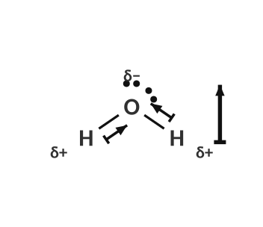
Water: bent, so the O–H arrows add up: polar.
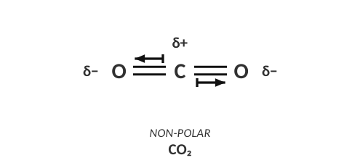
CO₂: two equal arrows in opposite directions cancel: non-polar.
2. CO₂ has polar bonds but is a non-polar molecule, while H₂O has polar bonds and is polar. Explain the difference using shape.

Practice: draw the arrows, decide polar or non-polar
For each molecule, draw an arrow on every polar bond (toward the more electronegative atom), then write POLAR or NON-POLAR and label any partial charges. Use the Lewis structures given.
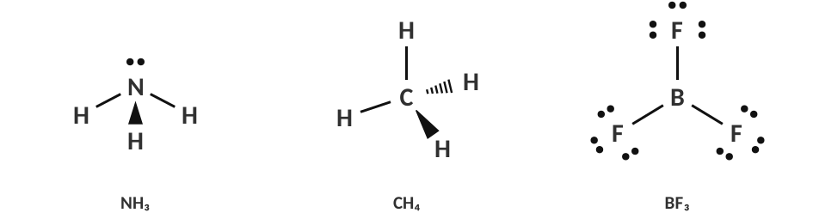
Molecule | Shape | Arrows cancel? | Polar or non-polar?
NH₃
CH₄
BF₃

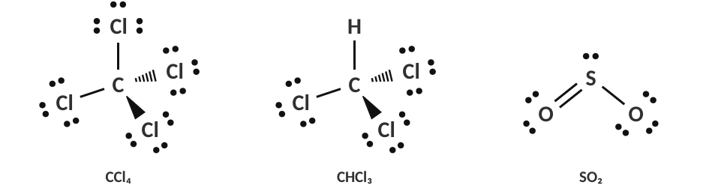
Molecule | Shape | Arrows cancel? | Polar or non-polar?
CCl₄
CHCl₃
SO₂

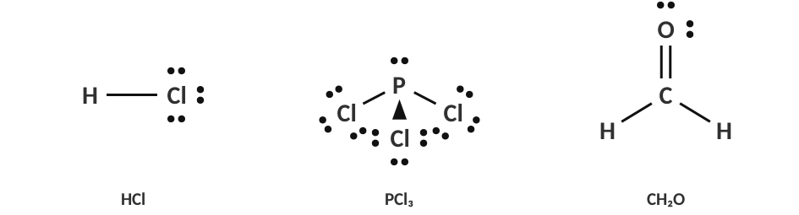
Molecule | Shape | Arrows cancel? | Polar or non-polar?
HCl
PCl₃
CH₂O

3. Compare CCl₄ and CHCl₃. Both are tetrahedral with polar C–Cl bonds. Why is only one polar?

Rules of thumb for shapes
Shape | Same atoms on every position, no lone pairs on the central atom | Otherwise (lone pairs or different atoms)
Linear
Trigonal planar
Tetrahedral
Bent / pyramidal / seesaw / T-shaped
Octahedral / trigonal bipyramidal

LAB CORNER • Bending a stream of liquid

A charged plastic rod is held near a thin stream of liquid that is falling from a buret. Water’s stream bends toward the rod; hexane’s stream does not.
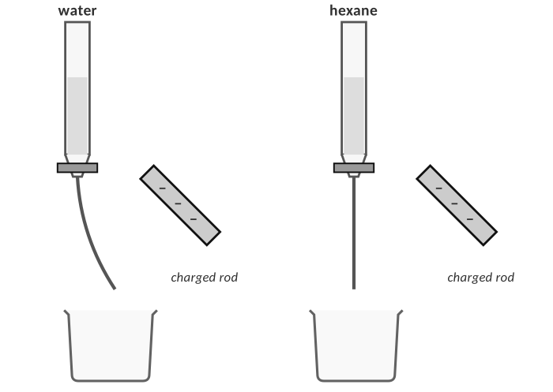
Stream deflection demonstration.
4. Explain the observation for water at the particle level. Draw a quick sketch of how the water molecules line up near the negative rod.

5. Hexane (C₆H₁₄) is not deflected. What does that tell you about hexane?

6. If the rod were positively charged instead, would the water stream bend toward it or away from it? Explain.

7. Which bond is the most polar?
A) C–H
B) H–Cl
C) H–O
D) H–F

8. Which molecule is non-polar even though it has polar bonds?
A) H₂O
B) NH₃
C) CO₂
D) HCl

9. Which molecule is polar?
A) BF₃
B) CCl₄
C) PCl₃
D) CH₄

10. What does the arrow in a bond dipole point toward?
A) the less electronegative atom
B) the more electronegative atom
C) the central atom
D) the nucleus

PRACTICE
Extra Practice — Unit 3
Show all work.

A. Ions and compounds
Element | Valence e⁻ | Loses or gains? | Ion symbol and charge
Magnesium
Chlorine
Oxygen
Lithium
Phosphorus
Calcium

Metal + non-metal | Ions formed | Formula
potassium + sulfur
aluminum + chlorine
magnesium + nitrogen
calcium + fluorine
aluminum + oxygen
sodium + phosphorus

B. Classify and predict properties
Compound | Ionic or covalent? | Expected state at 25 °C | Conducts when dissolved?
CaBr₂
CH₃OH
N₂O
Li₂S
C₁₂H₂₂O₁₁
SrCl₂

A student tests four unknown white solids. Use the data to decide whether each is ionic or covalent.
Solid | Melting point | Conducts as a solid | Conducts when dissolved | Ionic or covalent?
W | 801 °C | no | yes
X | 186 °C | no | no
Y | 2072 °C | no | yes
Z | 54 °C | no | no

1. Explain how you decided for solid Y, using particles and attractions.

C. Lewis structures, shapes and polarity
Formula | Lewis structure | Shape | Angle | Polar?
H₂S
CCl₄
BeCl₂
NF₃
CS₂
SF₆
CH₂Cl₂
SF₄

Bond summary: from formula to polarity
Formula | Bond type (ionic / polar covalent / non-polar) | Shape | Polar molecule?
NaCl
HF
Cl₂
PCl₃
CO₂
C₂H₆

D. Explain it
2. Explain why solid NaCl does not conduct electricity but molten NaCl does.

3. A student claims, “Covalent bonds are weaker than ionic bonds, so covalent compounds melt at low temperatures.” Evaluate the claim.

4. Draw the Lewis structures of CO₂ and SO₂. Why does one have a bent shape and the other is linear? Which is polar?

5. The bond angle in NH₃ is 107° but in CH₄ it is 109.5°. Explain.

6. Use polarity to explain why oil and water do not mix. (Hint: think about the stream demo.)

E. Multiple choice
7. Which compound contains BOTH ionic and covalent bonds?
A) NaCl
B) NH₄NO₃
C) CO₂
D) CH₄

8. What is the shape of the sulfate ion, SO₄²⁻?
A) trigonal planar
B) tetrahedral
C) trigonal pyramidal
D) octahedral

9. Which of the following molecules has a triple bond?
A) O₂
B) N₂
C) Cl₂
D) H₂O

10. A molecule with the shape ‘seesaw’ has how many electron domains on the central atom?
A) 3
B) 4
C) 5
D) 6

11. Which pair has the greater ΔEN?
A) C–H
B) N–H
C) O–H
D) Cl–Cl

TOPIC  ★ | Unit 3 Review  Put it in your own words before the test

1. Compare ionic and covalent bonding: which elements, what happens to the electrons, and what the compounds are like.

2. Describe the five steps you follow to go from a formula to a Lewis structure.

3. What does VSEPR stand for and how do you use it to predict a shape?

4. Explain how a molecule can have polar bonds but be non-polar. Give an example.

Concept map
Make your own concept map using: octet, ionic, covalent, Lewis structure, VSEPR, shape, polarity, melting point

